**Download and run instructions:**

1. Clone the repository:

git clone <https://github.com/biorobaw/NSL-Java.git>

In the example below the repository was cloned in the Desktop folder so the project base directory is “D:\Users\bucef\Desktop\NSL-Java”

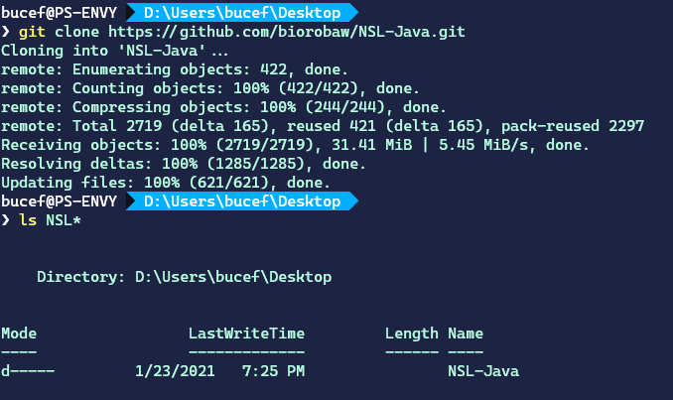

1. Open eclipse using the project base folder as the workspace directory. Following our example, it should look something like the following image.

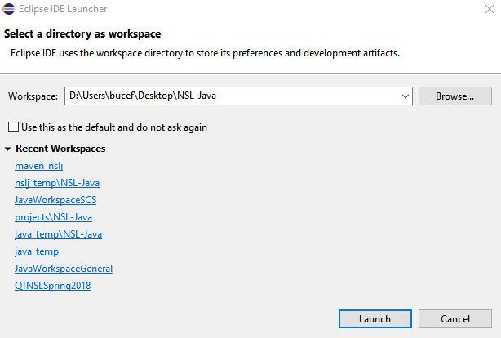

**2**

**1**

1. Import maven projects ‘nslj’ and ‘generative_pc_model_gonzalo’ into the workspace:
   1. File->import…
   2. Choose ‘Existing Maven Project’
   3. Set root directory to the project base folder, select both projects to be imported, and then click finish.
2. Create a run configuration and then run model ‘generative_pc_model_gonzalo’
   1. Click the down arrow next to the run button (as shown in the image), and click ‘Run configurations…’
   2. Create a new configuration by double clicking ‘Java Application’ and assign it any name
   3. In tab ‘Main’, make sure the selected project is ‘generative_pc_model_gonzalo’, and set ‘Main class’ to ‘com.github.biorobaw.nslj.main.NslMain’.
   4. In tab arguments, set ‘Program Arguments’ to ‘com.github.biorobaw.nslj_models.generative_pc_model_gonzalo.model.WGModel’

**3**

* 1. Click ‘Run’

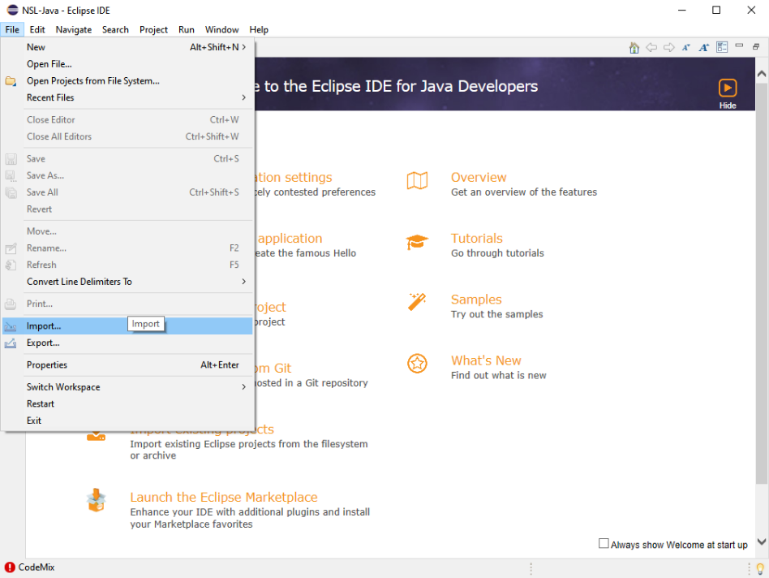

**6**

**4**

**9**

**8**

**7**

**5**

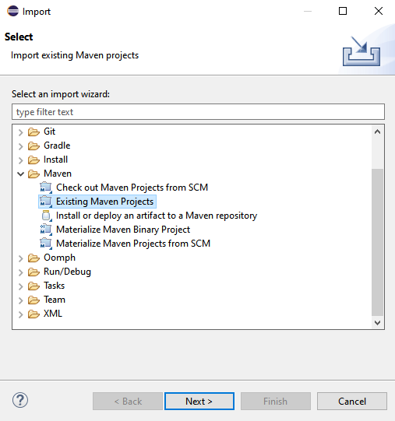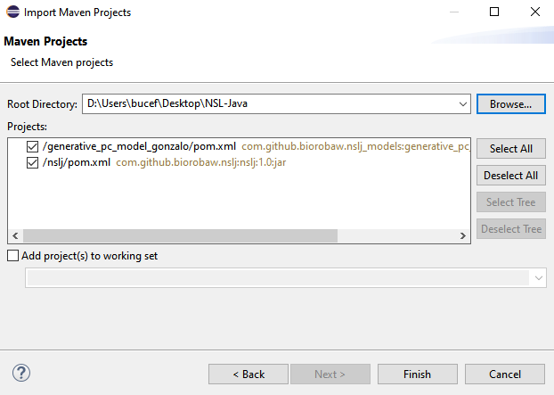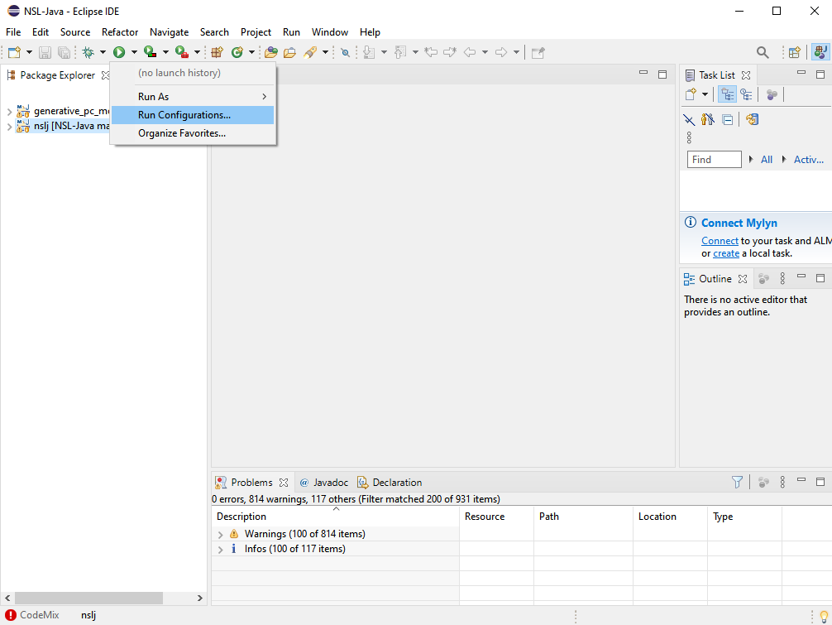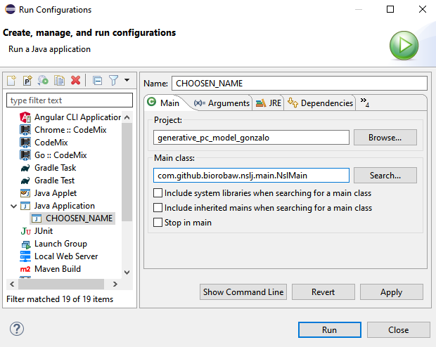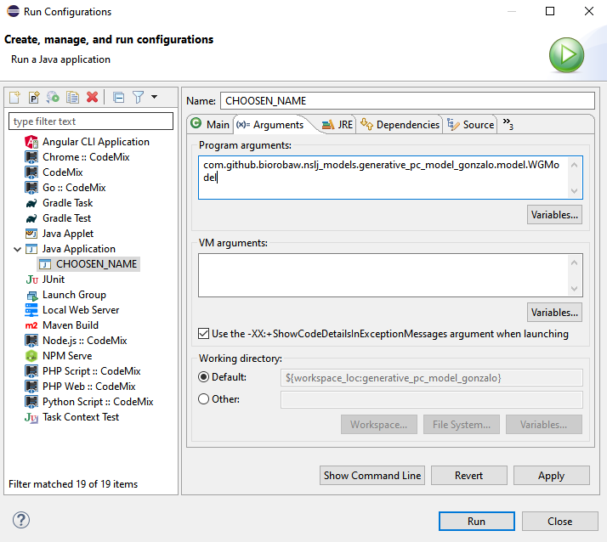

**10**

**11**

**15**

**13**

**14**

**19**

**18**

**17**

**16**

**12**

1. Run the simulation by choose ‘Run’ from the the ‘Run’ drop menu in the gui.

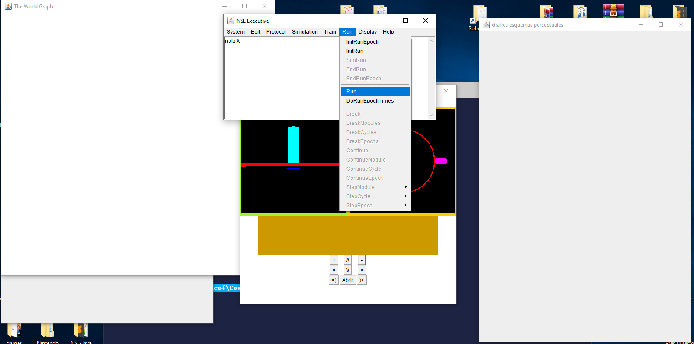

**21**

**20**

